This is my website………..

http://www.avirup.byethost31.com/

MOBILE VIEWS OF MY WEBSITE

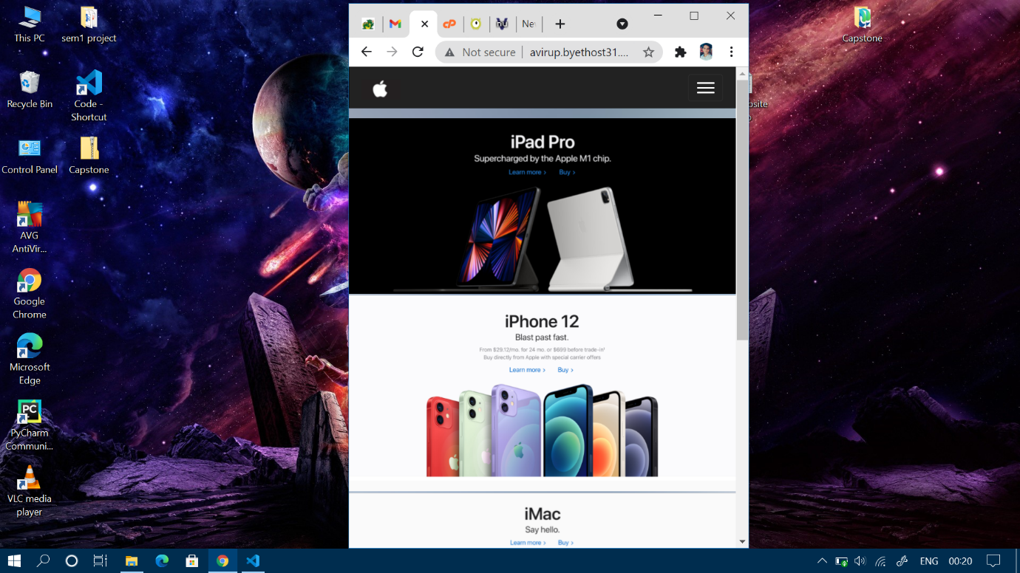

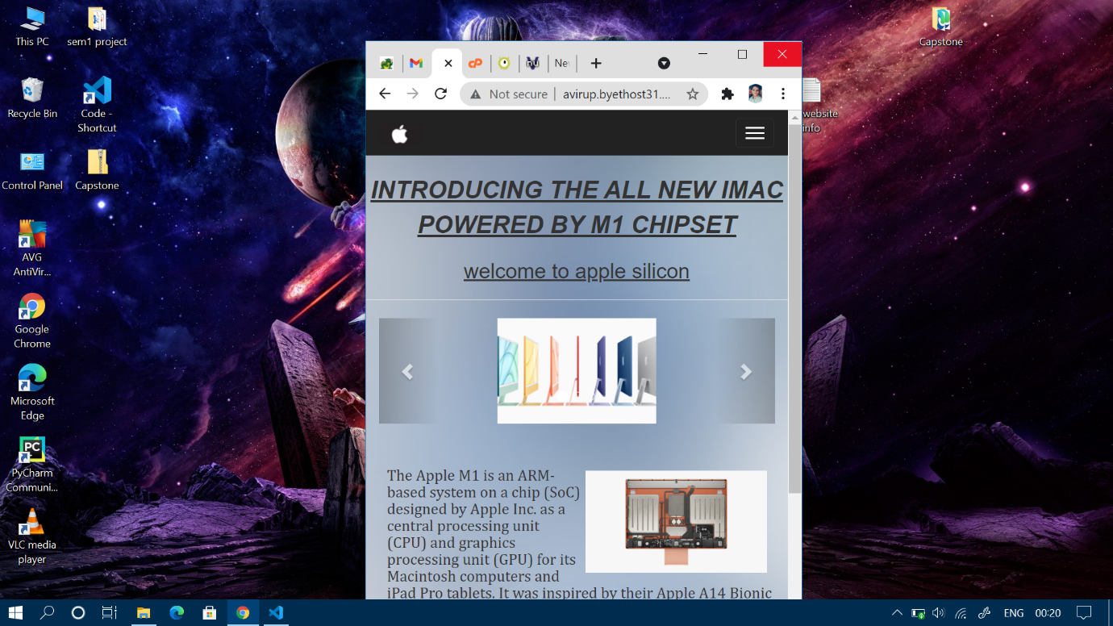

LARGER VIEW OF MY WEBSITE

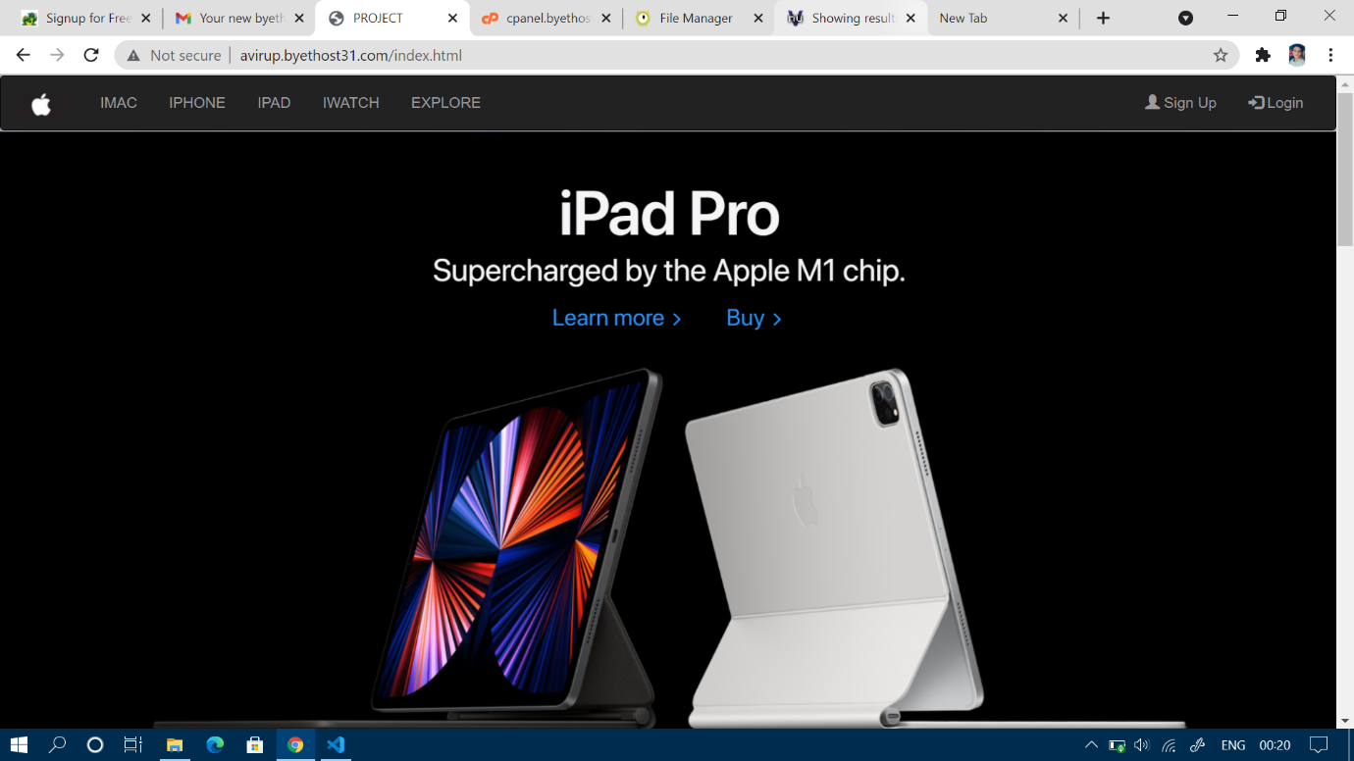

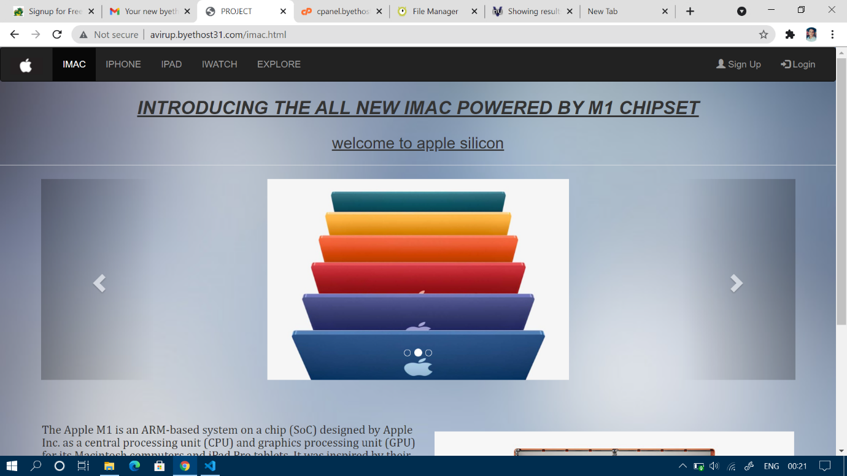

VALIDATOR

The errors shown are due to the free hosting service and not from my end.

